Is Gmail sending our emails to your promotions tab?

Here is how to move our emails to your Inbox, so that you never miss an important email…

Log into your gmail.com account, go to your Inbox, and click the Settings button

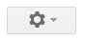

Then select the Settings option

If you want to get rid of your Promotions or Social tabs all together, select Configure inbox and check or uncheck the tabs as needed. Since our emails may be going to your Promotions tab, you would uncheck the box that says Promotions

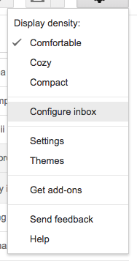

If you want to keep all of your Promotional emails OUT of your Inbox, you can select only emails from achs.edu to be sent to your Inbox.

Under Settings, select Settings

Select the option for Filters and Blocked Addresses

On the right side, click Create a new filter
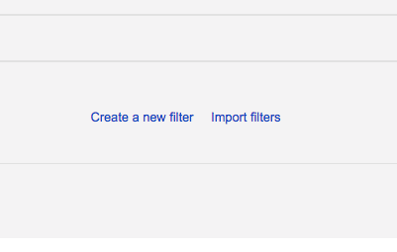

Enter @achs.edu in the From field and click Create filter with this search

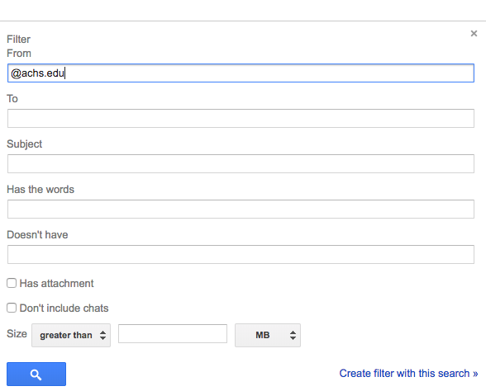

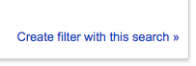

Change the last options to Categorize as: Personal and click Create filter (Be sure to click the box to apply this to the emails currently in your inbox.)

